DEVICE DRIVERS FINAL LAB EXAM

-CED17I041

Q) Write a C program to capture the key strokes of capital letters.

Output Explanation:

S1.Making module.

S2.Inserting module.

S3.Entering random strokes with capital letters, small letters and some special letters.

S4.Capturing only capital strokes.

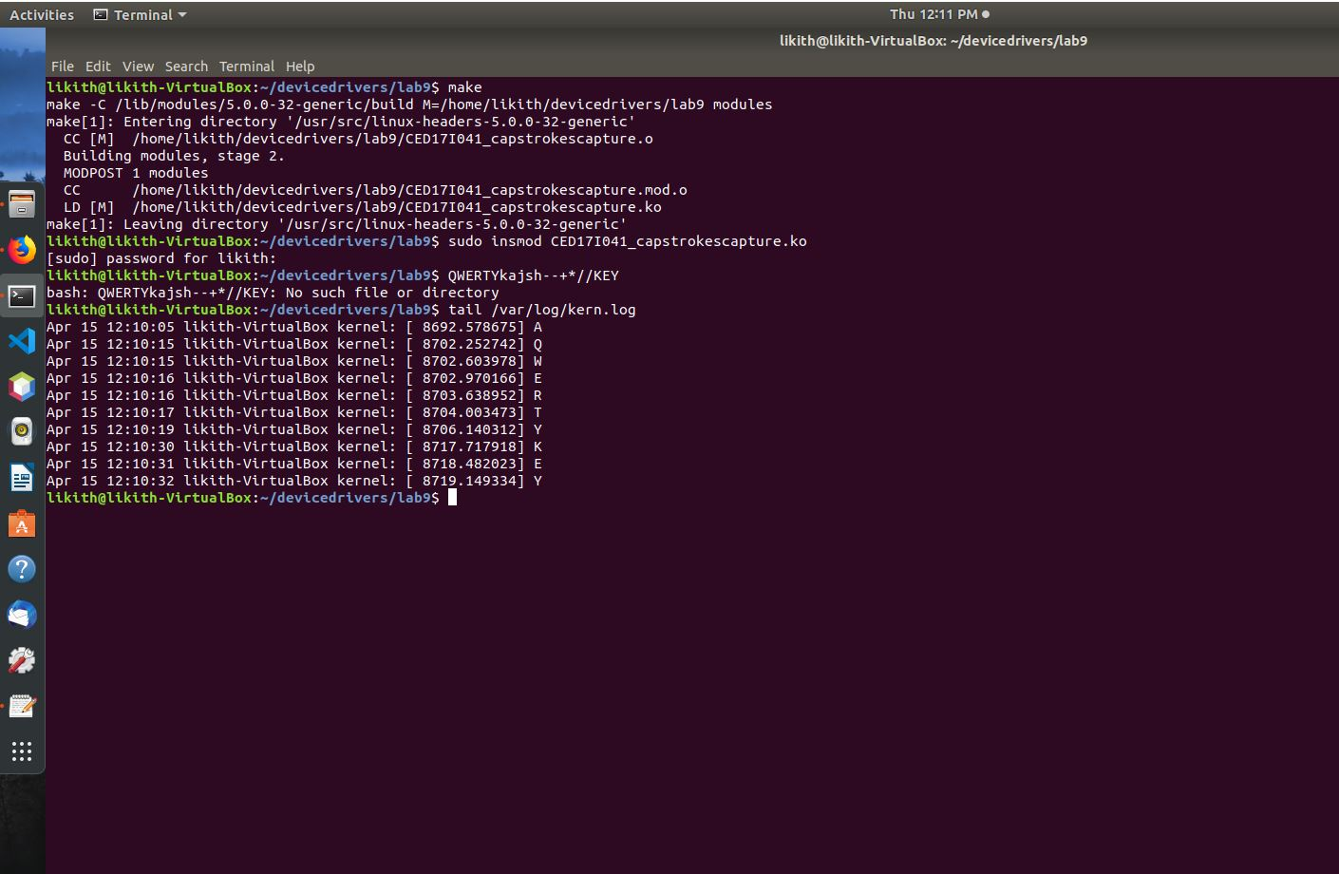

d